AP Biology Review Concept Maps
We are almost done! Our final assignment before the final exam is to create, present, and assess concept maps on the major topics from this year. You may work with up to 2 people to complete your concept map. You will present the map to the class. This map may be digital, i.e. a prezi, or physical (see the ones around the room). You will then give an assignment that goes along with that map. This may be a quiz, assignment, or online assessment, but it must be gradable and recordable. It must contain no fewer than 10 questions related to your concept map. Below is the rubric for your concept map. You should have key terms and phrases in your map and speak about them in more detail. Try to use fewer than 10 words in each bubble.

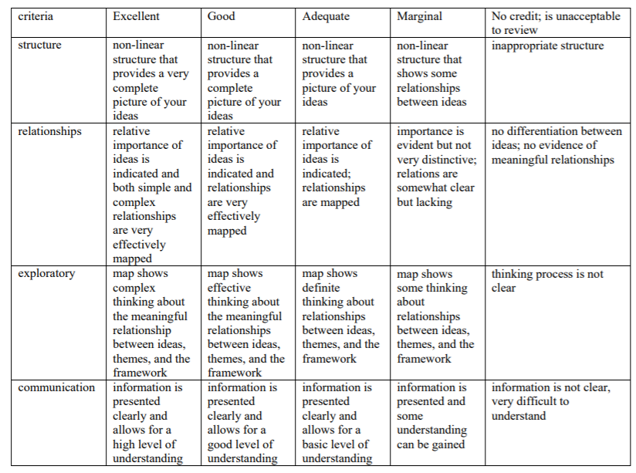

You must pick from the following topics. Only one group may complete each topic.
Biochemistry
Cells
Cell Energy
Evolution
Genetics
Molecular Genetics
Ecology
Diffusion, osmosis, communication
Cell reproduction and growth

