CREATE YOUR OWN CONCEPT MAP ON BODY TISSUES
1. Start with your center concept - TISSUES OF THE BODY
2. Draw 4 arrows connecting to the four types of tissues found in the body.
3. From each tissue type, draw arrows (varies in number) to related types
4. For each you want to include linked concepts that describe the tissue type, indicate where it is located, and any additional related terms
This image might help get you started. You will need to copy this onto your own paper (unlined) and complete it.
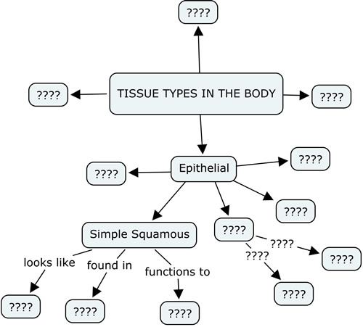
GRADING RUBRIC
 | 4 pts  All tissue types are represented, thoroughly and accurately, multiple connections show relationships, appropriate terminology used, functions listed | 3 pts  Most tissue types are represented accurately, multiple connections show relationships, appropriate terminology used, most functions listed, some additional terms are included for clarity | 2 pts  Some types are listed for the category, enough to show knowledge of the topic, some additional terms are included for clarity | 1 pts  Some types are listed for the category, knowledge skethcy; connections may be sloppy, not all functions listed, no additional terms to clarify topic
Epithelial
Connective
Muscular
Nervous
 | Neatness / Organization | Terms / Vocabulary | TOTAL POINTS  _____Types (out of 16)  _____Neatness, Links, Terms (4)  TOTAL ______ out of 20
OVERALL | Able to follow, on unlined paper, legible, takes up most of the page  0 1 2 | Spelled correctly, used appropriately  0 1 2

