Histology physiology review
Circle the correct answer
1. A tissue is: a collection of nuclei / a collection of organelles / a collection of cells / a collection of organs.
2. The four major tissue types are: epithelial / fat / connective / bone / muscle / nervous / blood.
3. Epidermal tissue: protects and supports the body / covers body surfaces / is responsible for movement / lines hollow organs / transmits nerve impulses / forms glands.
4. The inside of blood vessels is lined with: cuboidal epithelium / squamous epithelium / transitional epithelium / columnar epithelium.
5. The tissue illustrated below is: cuboidal epithelium / adipose tissue / squamous epithelium / loose connective tissue / blood.
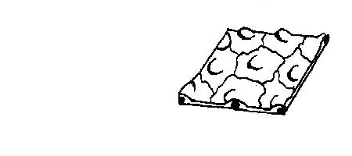
6. The kidney tubules are lined with: cuboidal epithelium / squamous epithelium / transitional epithelium / columnar epithelium?
7. Where is ciliated columnar epithelium NOT found : in the kidney tubule / lining the fallopian tubes / lining the trachea / lining the small intestine?
8. Stratified epithelia: were laid down many centuries ago / are more important than other tissues / consist of several layers of cells / always occur in straight lines.
9. Transitional epithelium allows the: arteries to expand / skin to stretch / uterus to contract / bladder to stretch.
10. The tissue illustrated below is: squamous epithelium / columnar epithelium / squamous stratified epithelium / transitional epithelium / lymph
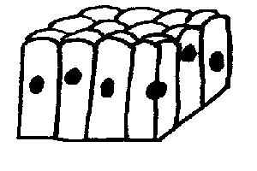
11. Non keratinised stratified squamous epithelium does NOT OCCUR: lining the vagina / covering the body / lining the mouth / lining the uterus.
12. The surface cells of keratinised stratified squamous epithelium are continually: dying / changing shape / being recycled / being shed from the surface.
13. Which of the following are NOT found in connective tissue?:Cells / fibres / minerals / fluid matrix / cilia.
14. Which of the following are NOT connective tissues: blood / fingernails / tendon / bone / saliva / adipose tissue / cartilage?
15. Which of the following muscle tissues has branched fibres, intercalated discs between adjacent cells and contracts automatically: striated voluntary muscle / smooth involuntary muscle / cardiac muscle?
16. Which of the following muscle tissues has long fibres with cross bands and nuclei on the surface? Striated voluntary muscle / smooth involuntary muscle / cardiac muscle?
17. Which muscle tissue moves bones? striated voluntary muscle / smooth involuntary muscle / cardiac muscle.
18. The tissue illustrated below is: striated muscle / blood / squamous epithelium / cartilage / transitional epithelium
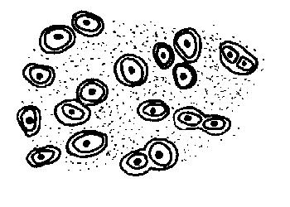
19. Which muscle tissue is found in blood vessel walls, in the gut wall and in glands? striated voluntary muscle / smooth involuntary muscle / cardiac muscle.
20. The tissue illustrated below is: striated muscle / tendon / smooth muscle / transitional epithelium / cardiac muscle
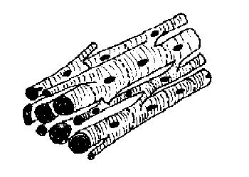
21. Match the tissue type with the function.
Tissue type | Function
a. Connective Tissue | A. Communicating
b. Muscle Tissue | B. Supporting & communicating
c. Epithelial Tissue | C. Contracting
d. Nervous Tissue | D. Covering and lining

