Biology Lab Name __________________________
Chapter 1 The Nature of Science Period __________
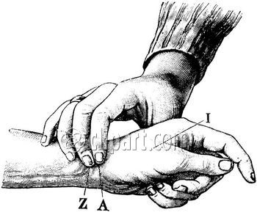
The Effects of Standing, Hopping, and Holding Breath on Pulse Rate
/20
Purpose:
1. To use the scientific method to solve a problem.
2. To observe how resting pulse rate is affected by standing,
holding your breath, and hopping for 30 seconds.
Hypothesis: Write a hypothesis for each of the following comparisons:
1. Pulse while resting vs. standing: ______________________________________________________________
2. Pulse while resting vs. holding your breath: _____________________________________________________
3. Pulse while resting vs. hopping for 30 seconds: __________________________________________________
Materials: Clock with second hand, calculator (optional)
- Procedure:
- 1. While sitting quietly at your desk, find the pulse in your wrist and count the beats for 30 seconds and record in data table below. Take your resting pulse rate again and record. Calculate your average resting pulse rate and record.
- 2. Stand at your desk for one minute. After one minute, count your pulse rate for 30 seconds and. Take your standing pulse rate again and record. Calculate your average standing pulse rate and record.
3. While holding your breath, count your pulse rate for 30 seconds and record. Take your pulse rate while holding your breath again and record. Calculate your average pulse rate and record.
4. Hop for 30 seconds by then immediately count your pulse rate for 30 seconds and record in data table below. Repeat and record. Calculate your average pulse rate after hopping and record.

Pulse Rate (number of beats / minute)
 | Resting | Standing | Holding Breath | Hopping 30 sec.
1
2
Your Average
Class Average

5. Record your average pulse rates in the class data table on the overhead projector.
6. After all students have recorded their own average pulse rates and the class average is computed, record the class average for each pulse rate.
Results:
1. What is the dependant variable that was measured in this experiment? ________________________________

2. Why was the pulse rate for each activity taken twice? ______________________________________________

3. What is the independent variable in this experiment _____________________________________

4. What is the control setup in this experiment? ______________________________________________________

5. What is the purpose of the control? _____________________________________________________________

6. Why is the class average more useful for comparing than your average? _______________________________
__________________________________________________________________________________________

7. List 3 other variables (besides type of activity such as running, sleeping, etc.) that could affect your pulse rate.
a. ___________________________ b. ____________________________ c. ___________________________

8. List 2 possible sources of error in this experiment.
a. ____________________________________________ b. ____________________________________________

9. Make a bar graph of the class averages and your own averages in the space below. Be neat and accurate. Label both x- and y-axis (include units). Choose an appropriate scale on the y-axis. Use color to draw bars. Include
key.

Key:
my average
class average

Conclusion: Write a 4 or more sentence conclusion that includes a statement of purpose, summary of results, interpretation and analysis, and a closing statement.
1. Purpose (Tell me what the point of this lab was): ___________________________________________________________

_____________________________________________________________________________________________

_____________________________________________________________________________________________

2. Results (Describe the main outcomes that you observed): _____________________________________________________

_____________________________________________________________________________________________

_____________________________________________________________________________________________

3. Analysis (Explain why you got your results or anything that went wrong): __________________________________________

_____________________________________________________________________________________________

_____________________________________________________________________________________________

4. Closing (Tell me what you learned): ___________________________________________________________________

_____________________________________________________________________________________________

