Speed and Velocity

Average speed

Average speed=( )=(v)= ____________________

Vector quantity velocity = ___________________________

Units

Displacement ( )

Time ( )

Velocity ( )



Average of two velocities

Position- Time Graphs

Helpful in determining _________________________________________________________________

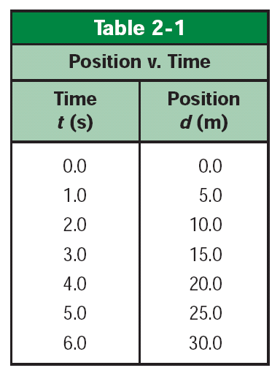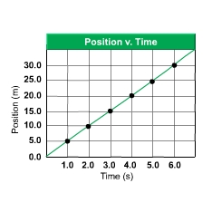

Equivalent Representations____________________________________________



What is acceleration?

Change in _______________________________________________________

Acceleration _______________________

A= ___________________________________________

Units

a= change in velocity /change in time

Acceleration can be____________________________ No such thing as deceleration

Negative acceleration means _______________________________________

Graphing acceleration

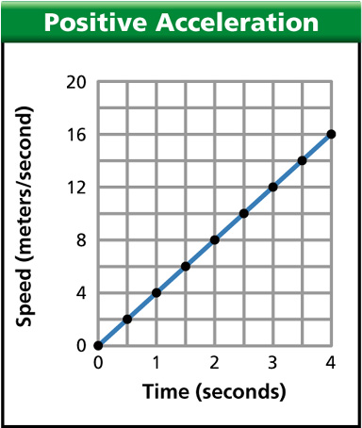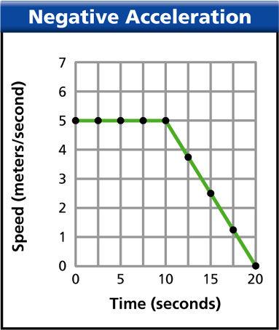

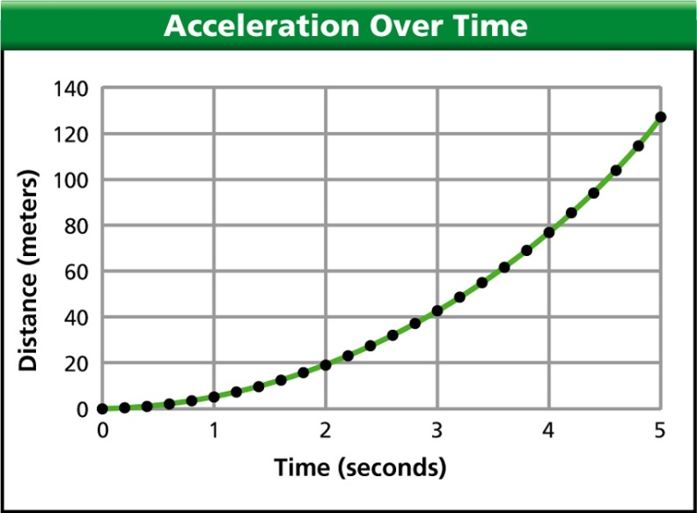

Free fall _________________________________________________________

Symbol _____________=__________________________________