Chapter 6 Notes
pH Scale: ___________________________________________________________________________
14
7
1

4 Organic Molecules
- _____________________________
- _____________________________
- _____________________________
- _____________________________
Monomer:____________________________________________________________________________
Polymer:______________________________________________________________________________

- Carbohydrates:__________________________________________________________________
Building Blocks:___________________________________________________________
Many monosaccharides make up ________________________________.
- ______________________________________________________________
- ______________________________________________________________
- ______________________________________________________________
- ______________________________________________________________
Function:________________________________________________________________
Foods: __________________________________________________________________
Test for Starch:___________________________________________________________
- Lipids: _________________________________________________________________________
Building Blocks: ___________________________________________________________
Functions: _______________________________________________________________
Types: __________________________________________________________________
Test: ___________________________________________________________________
- Nucleic Acids: ___________________________________________________________________
Building Blocks: ___________________________________________________________
Functions: _______________________________________________________________
- Proteins: _______________________________________________________________________
Building Blocks: ___________________________________________________________
Types: __________________________________________________________________
Enzymes: ________________________________________________________________
Enzyme Diagram:
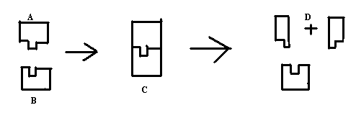
Enzyme Graph:

