Cranial Nerves Coloring
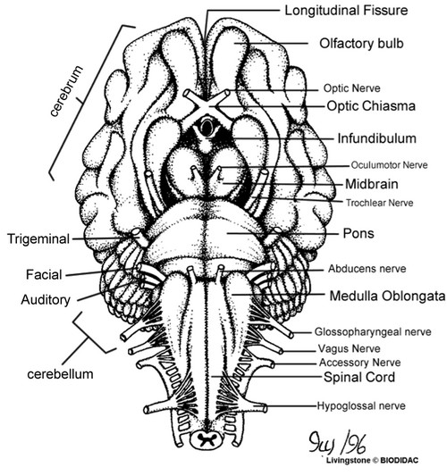
The sheep brain below has many parts labeled and shows the cranial nerves.
*Number the cranial nerves appropriately.
Color each part according to the keys. The next page will show a similar image of a human brain.
Olfactory bulb and tract (purple)
Optic Nerve and Chiasma (dark green)
Oculomotor (dark blue)
Trochlear (gray)
Trigeminal (pink)
Abducens (orange)
Facial (yellow)
Vestibulocochlear / Auditory (red)
Glossopharyngeal (black)
Vagus (brown)
Accessory / Spinal Accessory (dark blue)
Hypoglossal (orange)
Cerebellum (light green)
Cerebrum (light blue)
Pons (red)
Medulla Oblongata (purple)

HUMAN BRAIN
*Number the cranial nerves appropriately.
Color each part according to the key. This picture is not labeled, you may use other resources to help you locate the structures.
Olfactory bulb and tract (purple)
Optic Nerve and Chiasma (dark green)
Oculomotor (dark blue)
Trochlear (gray)
Trigeminal (pink)
Abducens (orange)
Facial (yellow)
Vestibulocochlear / Auditory (red)
Glossopharyngeal (black)
Vagus (brown)
Accessory / Spinal Accessory (dark blue)
Hypoglossal (orange) Pons (red)
Medulla Oblongata (purple)
Pons (red)
Cerebellum (light green)
Cerebrum (light blue)
