Motion Notes
Perceiving motion is _______________________________________________
Movement travels in___________________________________________
Relative Motion _________________________________________________
Particle Model

Coordinate System: tells you __________________________________________
x-y coordinate _____________________________________________________
Displacement ______________________________________________________
D=df-di
Distance________________________________________________
_______Quantity
Displacement_______________________________________________________
________quantity
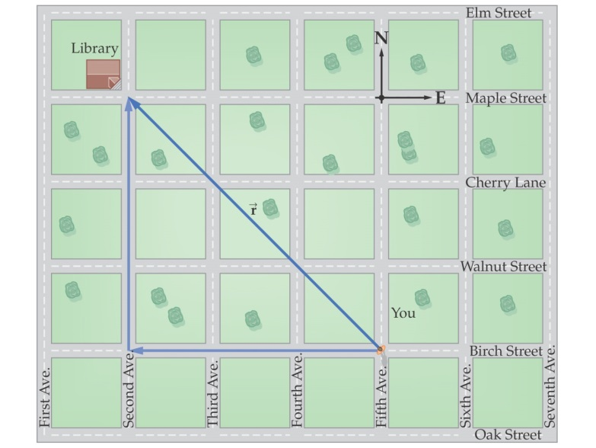
Scalar
Magnitude__________________________________
Ex
Vectors
Magnitude and _____________________________
Ex
Vectors
Represented by _______________________
Direction represents___________________________________
Length of the arrow_____________________________________
Which is a vector
Temperature
Distance
Displacement
Resultant ________________________________________________

