Senses - Review Guide
1. Describe the different types of receptors.
2. Distinguish between the Meissner’s corpuscles and the Pacinian corpuscles.
3. Describe acute pain, chronic pain, and referred pain.
4. What is the difference between a somatic sense and a special sense?
5. How can pain be managed (name natural chemicals and pharmaceutical ones)
6. Define and give an example of sensory adaptation.
7. What are olfactory receptors and where are they located?
8. List the four different types of taste sensations and what triggers them. What is umami?
9. List all of the parts of the ear and their functions, identify which parts are associated with the outer, middle and inner ear.
10. Describe the path sound waves take within the ear and are eventually processed by the brain.
11. Be able to label the ear
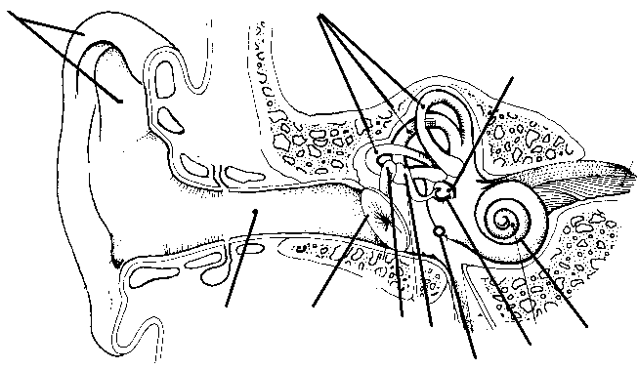
12. Compare static equilibrium to dynamic equilibrium (what part of the ear is responsible for maintaining your equilibrium?)
13. List all the parts of he eye and their functions. Know which parts are associated with the outer, middle, and inner tunic.
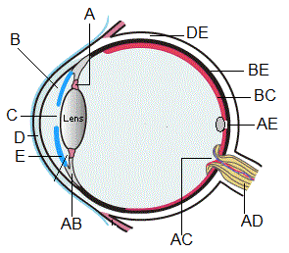
14. Describe the retina (rods and cones)
15. Describe how we see images and the part of the brain that interprets those images
16. Know what the blind spot is, where it is located and why it exists at all
17. Define refraction and discuss how it affects your vison.
18. What is the fovea centralis and why is it significant?
19. Explain why some people have myopia (nearsightedness) and some have hyperopia (farsighted). How are these conditions treated? What is astigmatism?
20. What are the muscles that move the eye called (also know locations).
22. What is a cataract and how is it treated?
23. Label the eye on a diagram.
24. What are the 6 major extrinsic eye muscles and how are they controlled, what cranial nerves?

