The Stickleback Fish - A Story of Modern Evolution

This activity uses a virtual lab created by HHMI Biointeractive. To complete this activity students will need a computer with an internet connection and headphones to access videos. This worksheet is modified from the student worksheet provided by HHMI. Also, make sure that your browser allows pop-up windows.

Background Infomation
Go to: biol.co/stickfish-bg and read the background information about the stickleback fish.
1. Summarize what happened to the fish in Loberg Lake, include an explanation for WHY it happened.

Stickleback Evolution Lab -- Go to: biol.co/stickfish
Introduction:
2. Define "model organism."

3. What is the purpose of the spines?

4. How did ancestral populations of ocean-dwelling fish come to live in freshwater lakes?

5. Watch the video about pelvic reduction in freshwater stickleback. The loss of the pelvic spines is similar to the loss of which body parts in other four-legged vertebrates?

6. Watch the video with evolutionary biology Dr. Michael Bell. Why is the threespine stickleback a model organism for studies in evolution. List at least two reasons.

7. Click on the link at the top of the page to go to the "overview," then click on the interactive fish. Describe the location of the stickleback spine.
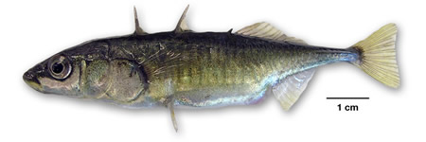
8. Watch the video about stickleback fish armor. In addition to the spines, what is another component of the armor of a stickleback fish?

Tutorial 1
9. What is the difference between a complete pelvis and a reduced pelvis?

10. Start the tutorial by clicking on the tray of fish, practice scoring the fish until you feel you have mastered the technique. Which do you think is the best view (lateral or ventral) for determining the type of pelvis?

Experiment 1
11. Click on Experimment 1 and read the objective. Summarize, in your own words, the objective of Experiment 1.

12. Click on the link to the map of Alaska, and then click on the blue pin "A" to see a larger map. You will notice there are many small lakes in this area. One lake you will study is Bear Paw Lake. Name two other lakes in this region.

13. Watch the video of the scenery around Cook Inlet. What other types of animals are present in this environment (as seen on the video)?

14. Click on "Part 1" in the menu at the top and watch the video on how the fish were caught. Describe the method biologists use to trap the fish.

15. Click on "Part 2" in the menu at the top and watch the video on stickleback poulation in Bear Paw and Frog lakes. Describe the major differences between these two lakes.

16. Click to read more about the importance of random sampling. Why are random samples used rather than the entire population?

Give an example of sampling bias.

17. Go to the experiment by clicking on the blue gloves in the lab window. Click on "Skip Part 1: Staining." You will go straight to scoring the fish, just like you did in the tutorial. The program will keep track of your fish scores.
After you have scored all of the Bear Paw Lake fish, indicate the number that were:
Absent _____ Reduced _____ Complete _____
After you have scored all of the Frog Lake fish, indicate the number that were:
Absent _____ Reduced _____ Complete _____
18. Use a bar graph to graph your data. Be sure to label all of your axes.
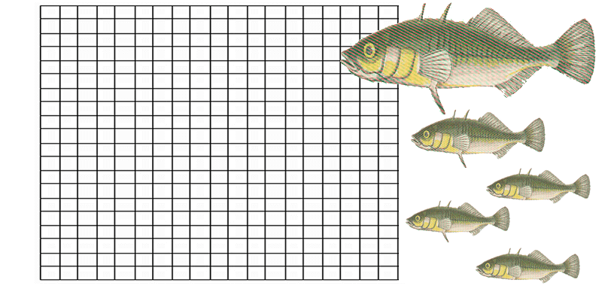

Analysis
____1. How did some ancestral sea-run stickleback populations come to live exclusively in fresh water?
- These populations swam to freshwater lakes to spawn and then never returned to the ocean because there were fewer predators in lakes.
- They became trapped in lakes that formed at the end of the last ice age.
- They don't actually live exclusively in fresh water; they only live in fresh water at certain stages in their lives.
- They developed traits that made them better adapted to fresh water and, as a result, had to move to a freshwater environment to survive.
____2. What happened to these fish as they adapted to living exclusively in fresh water?
- Over many generations, populations of fish changed in many different ways, including in their skeletons.
- They acquired new characteristics by mating with fish that lived in these lakes.
- Since the new environments were so similar to their old environments, their traits changed.
- The new environments caused individual fish to change within their lifetime.
____3. Why do some stickleback populations lack pelvic spines?
- In sea water, pelvic spines help fish swim faster, but not in fresh water.
- The pelvic spines are homologous to legs in four-legged animals. Because fish don't need hind limbs to walk, many populations of fish evolved to lack pelvic spines.
- In lakes where there are no predatory fish, there is no advantage to having pelvic spines.
- Pelvic spines are thought to attract mates for reproduction in the sea but not in lakes.
____4. In this virtual lab, why did you compare pelvic structures of stickleback populations from two different lakes?
- To have a larger number of specimens to score, increasing the accuracy of results.
- To compare the trait in stickleback populations living in two potentially different environments.
- Frog Lake and Bear Paw Lake are two lakes with very similar stickleback populations.
- One lake represents the control population and the other population is the one we can compare to the control.
____5. Which of the following is a definition of the process of natural selection?
- In each generation, some individuals may, just by chance, have more offspring than other individuals and their traits will become more common in that population.
- More advantageous traits in a particular environment allow individuals with those traits to have more offspring; as a result their heritable traits become more common in succeeding generations of the population.
- Mutations occur at random in a population causing populations to change over time as those mutations are inherited from one generation to the next.
- Only traits that are advantageous in a particular environment are preserved in the fossil record.
6. Consider that stickleback evolution has followed similar patterns in other lakes across the globe. Make a prediction about what would happen in an isolated lake with few predators where humans introduced predatory fish like trout. Support your prediction with evidence from the virtual lab.

